 |  | This space is for EVERYONE
As your public library, we welcome all people and care about being accessible to people with disabilities. For a copy of our Accessibility Plan, scan the QR code to the right or ask a staff member for a printed copy.  Library phone number  Library website  Library email address  INSERT YOUR LIBRARY LOGO HERE. DELETE THIS TEXT BOX, THEN RIGHT-CLICK THE IMAGE BEHIND IT AND SELECT “CHANGE PICTURE” |  | 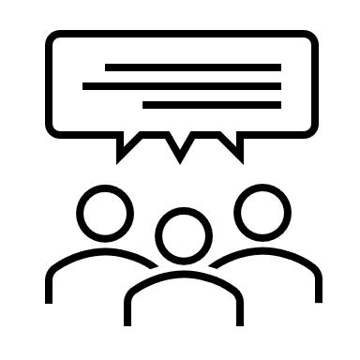  We’re glad you’re here.  Please share your thoughts, ideas and suggestions. Your feedback helps us improve.  nd ideas. By working together, we can accommodate everyone.  CREATE A QR CODE WITH THE LINK TO THE PLAN ON YOUR WEBSITE AND PLACE IT HERE. DELETE THIS TEXT BOX, THEN RIGHT-CLICK THE IMAGE BEHIND IT AND SELECT “CHANGE PICTURE”

